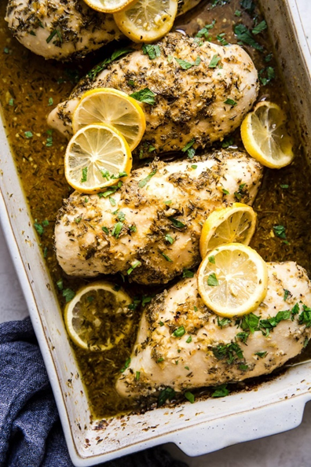Lemon Chicken

|  |
| --- |
| Ingredients With Measurements  * 4 boneless chicken breasts (roughly 2.5 lbs) * ¼ cup olive oil * 2 teaspoon oregano, dried * 2 teaspoon thyme, dried * 2 teaspoon garlic powder * 2 teaspoon salt, divided * ½ teaspoon black pepper * ½ cup dry white wine, such as Sauvignon Blanc, Pinot Grigio or Pinot Gris * 2 tablespoon minced garlic (6 cloves) * 1 tablespoon lemon zest (2 lemons) * 2 tablespoon lemon juice, freshly squeezed * 1 tablespoon brown sugar * 1 lemon |

|  |
| --- |
| Recipe Heat the oven to 400 degrees F.  Pat the chicken breasts dry and place them in a 9 x 13 baking dish.  In a small bowl, mix the olive oil, oregano, thyme, garlic powder, 1 teaspoon salt and pepper to create a thick marinade/paste. Coat the chicken breast with seasoning paste.  Using the same bowl mix together the white wine, garlic, lemon zest, lemon juice, brown sugar and remaining 1 teaspoon salt. Pour over chicken breast. |

|  |  |  |  |  |  |  |  |  |  |  |  |  |
| --- | --- | --- | --- | --- | --- | --- | --- | --- | --- | --- | --- | --- |
| |  |  |  | | --- | --- | --- | | Chicken Breasts | Olive Oil | Dried Oregano | | Dried Thyme | Garlic Powder | Salt | | Pepper | White Whine | Garlic | | Lemon Zest | Lemon Juice | Brown Sugar |  Ingredients Without Measurements |